How To Update The DS708 By Update Card

After one year, if you still want to update your DS708, You can buy the DS708 update Service from jobd2.jp. Then we will send you the DS708 update card, now I will teach you how to do it.

1.Sign in To your Autel Account

You need to go to the office website: www.auteltech.com, sign in to the account which corresponding the DS708 serial number need to upgrade, Please confirm the account can be used.

2.Enter the Autel ID and password as following picture:

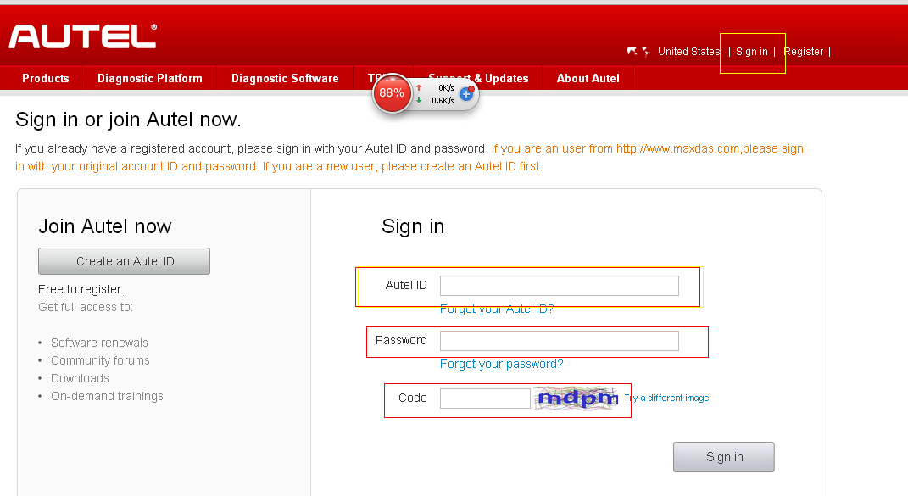

3. When you go to the account, Select the Redeem from the left

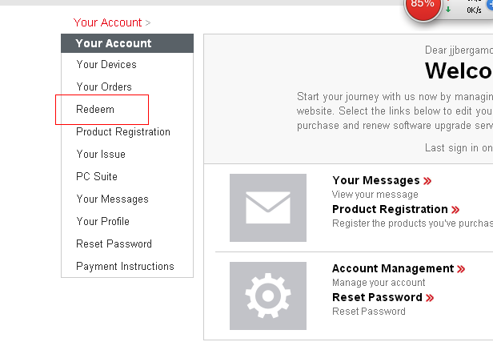

4. You will see the picture as this:
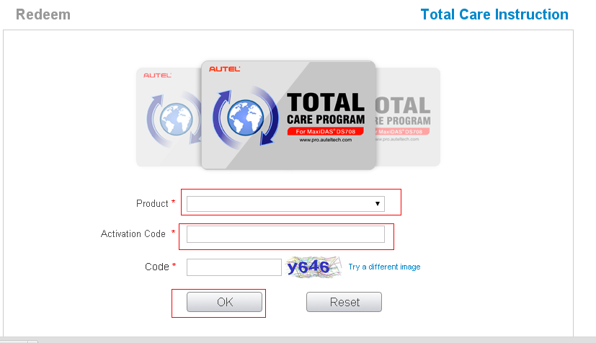

5.Insert information to the top of picture:

- Choose the Product, it will shows your DS708 Serial number
- Insert the Activation code
- Press OK to confirm
- Your DS708 one year update Online is completed

6. How To Get the Activation Code?
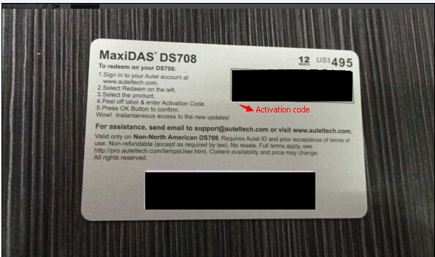

- Once you buy the DS708 Update service From us, we will send you the picture of DS708 update card. of course you can see the activation code and password from this two black site.

2)It only needs 5-10 minutes to update it by yourself.

3)If you really do not know how to do ,You can also offer us your Autel accout ID, Password and also your DS708 Serial number, we will help you do it.

Note:

1.If you have submitted more than 5 times of the wrong password in One day, the update service will be temporarily disabled.

2. This Update card is Disposable, which can only update one DS708

